Voice Call Web Panel

- Voice Call Web Panel Simplify The Calling Function.

- Using Voice Call Web Panel User Can Use Calling Function By Various Platforms like VoIP Devices, SIP Professional Voice Call Manager Software etc.

- Voice Call Web Panel Provide Various Calling Way Like Quick Call, Group Call, CSV Call By Simply Uploading an Audio File Of Any Formats.

- Voice Call Web Panel Also Provide Date Vise Calling Summary And Calling Report As Well.

Web Panel To VoIP Device Call

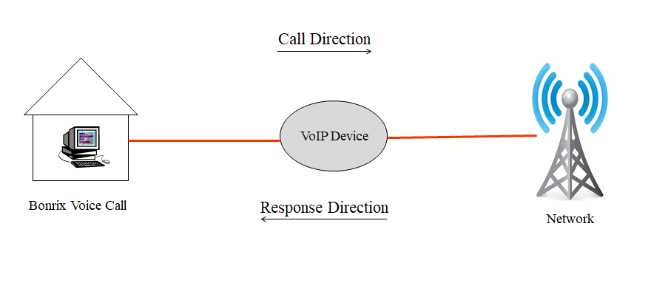
Web Panel To Software Call

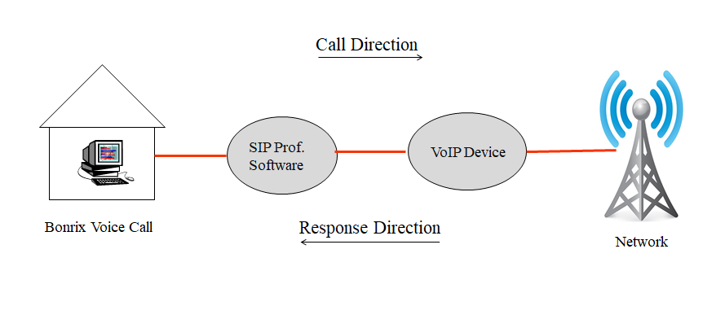
Bonrix Voice Broadcast Web Panel Description

- Description Bonrix Voice Broadcast Web Panel provides facility for only voice campaign for marketing purposes and also for transnational purpose for voice notification and Alert as well as OTP notification on voice call.

- This web provide re-seller option for selling voice call for voice marketing purpose.

- Android app also available for Bulk Voice campaign from android phone.

Bonrix Voice Broadcast Web Panel Use Cases

- Admin Panel:
Overall management and voice campain routing re-seller management, pricing and tariff management.

- Re-seller Panel:

User creation, User management, Credit allocation, reporting.

- User Panel:

Voice broadcasting, Voice sms, running voice marking campaign, upload pre-recorded audio file, upload bilk contact using Excel /CSV, Checking Voice report.

Different Type Of Voice Termination

- SIP - VOIP telephony provider connector.
- USB-3G data card dongle based voice to GSM dialer.
- GSM/3G Void GSM Gateway.
- Third party HTTP API for Voice and FTP audio file upload.
- Android app also available for Bulk Voice campaign from android phone.
- Voice API is also available for third party external software integration

SIP Professional Voice Call Software

- Bonrix VoIP SIP is developed for outbound call center for processing leads via different types of VoIP Gateway.

- It is developed for automated calling from desktop based phone working on different VoIP based technology.

SIP Professional Config.
Step 1: After installation of Voice call messenger user need to redirect Program files > Bonrix SIP Professional Voice call manager.

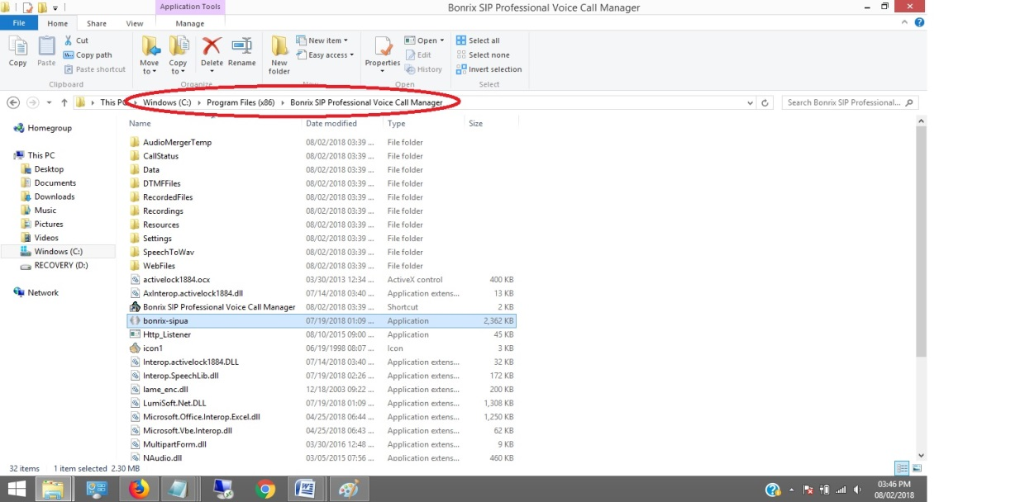
Step 2: User have to double click on bonrix-sipua.

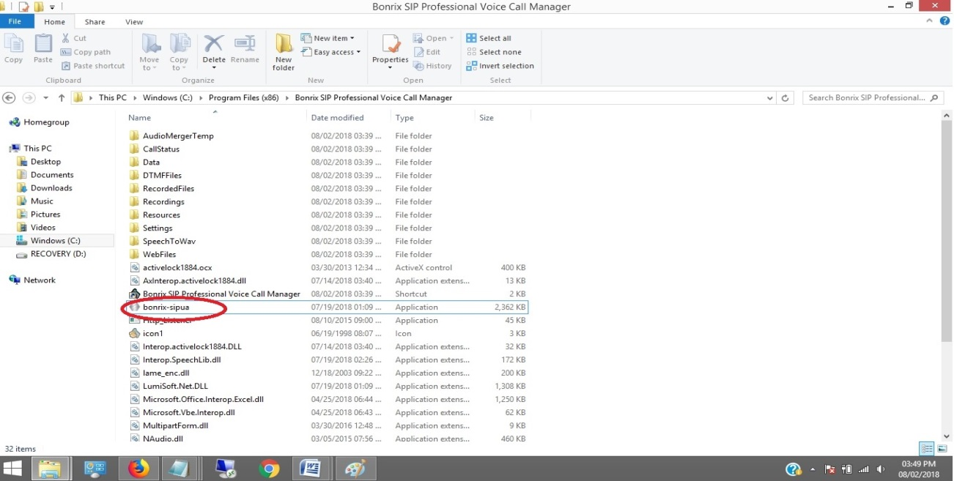
Step 3: After double click on bonrix-sipua User can see Bonrix SIP Auto Dialer software go to settings.

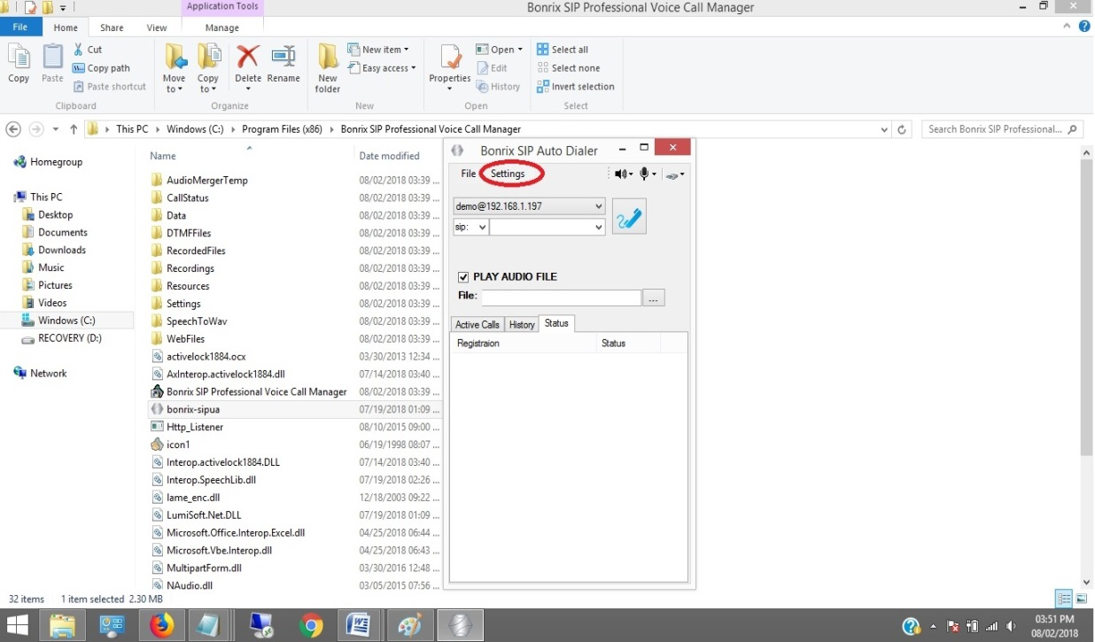

Step 4: In setting go to Bindings panel and set IP as shown in below screenshot.

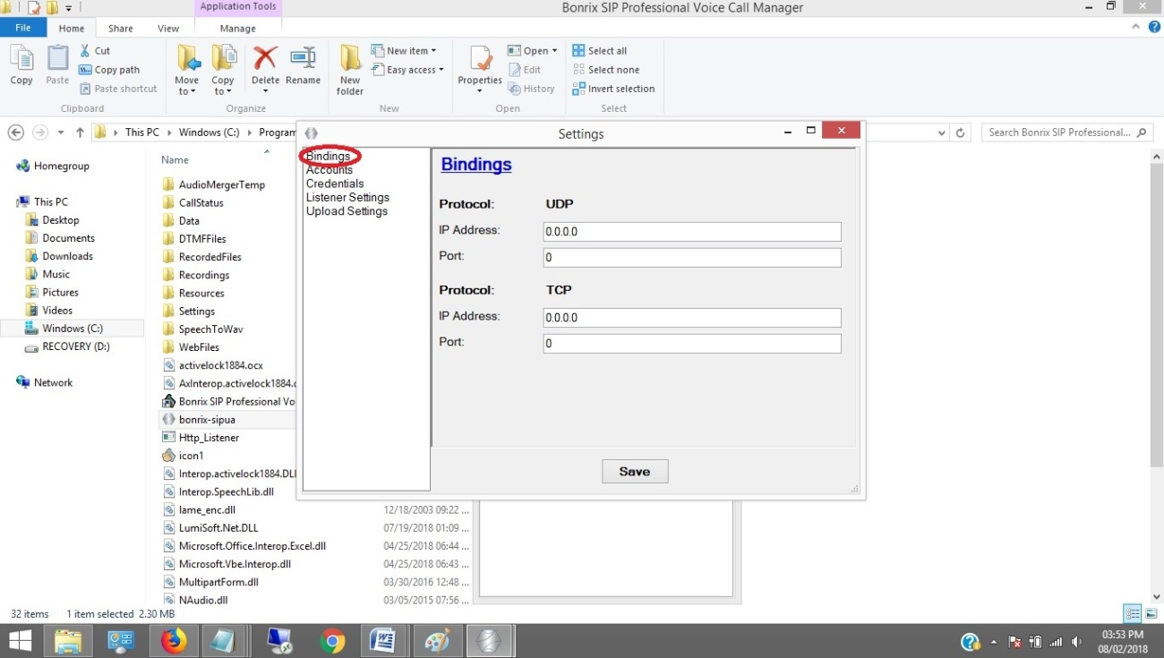
Step 5: Go to Accounts panel and set User name, AOR, User Proxy, Proxy Server, Register, Registrar Server, Register Interval as shown in below screenshot.

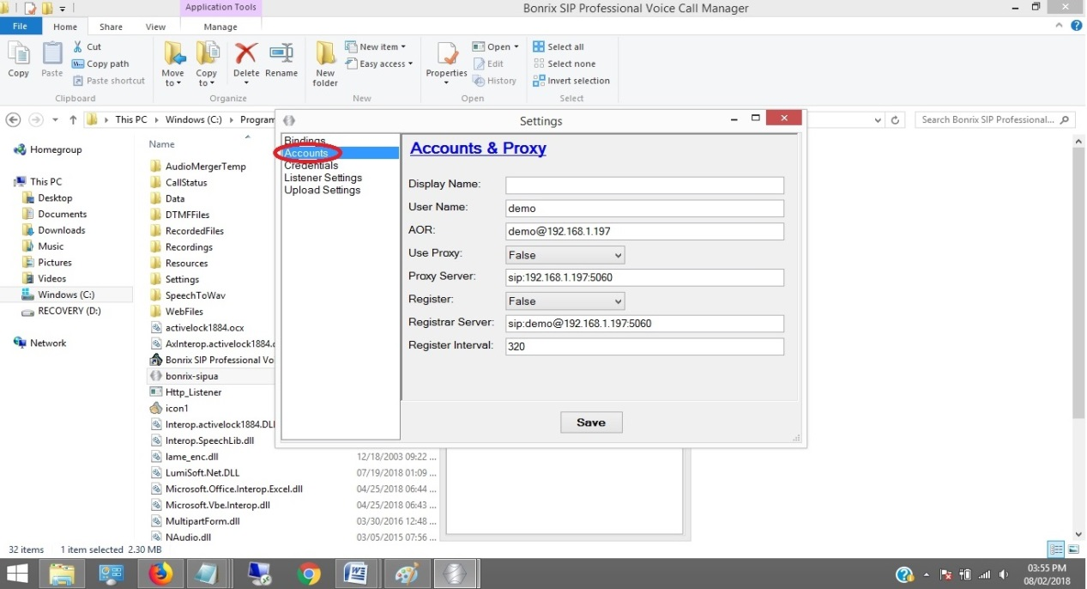
Step 6: Go to Credentials and set Domain, User Name, Password as shown in below screenshot.

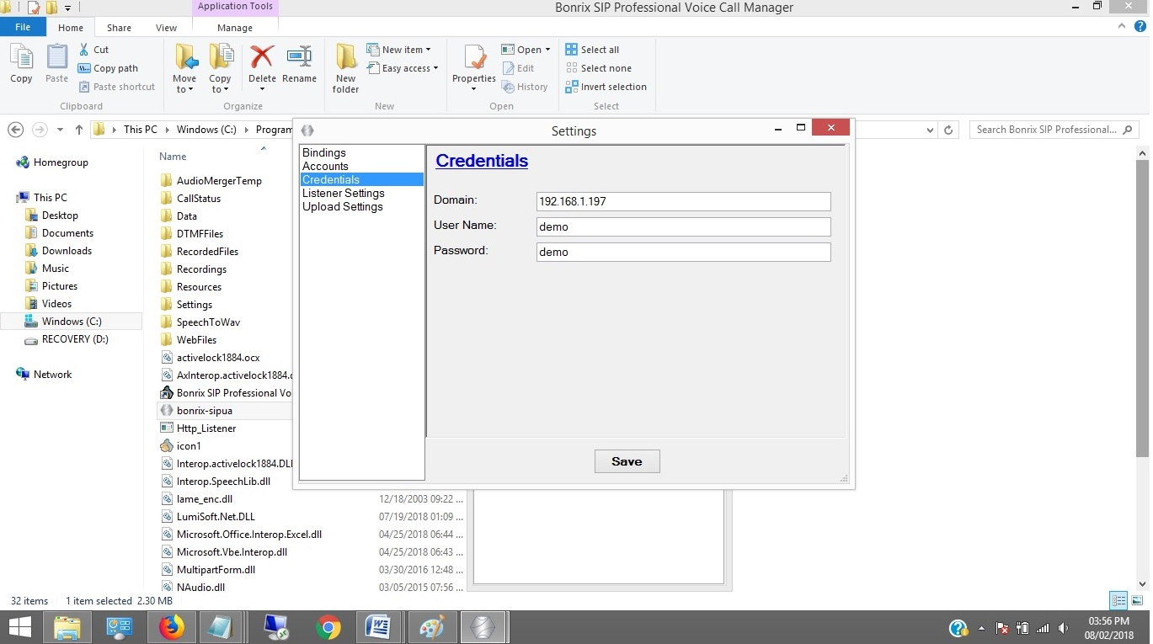
Step 7: Open Bonrix SIP Professional and go to Contacts panel then enter First, Last Name, Mobile no as shown in below screenshot.

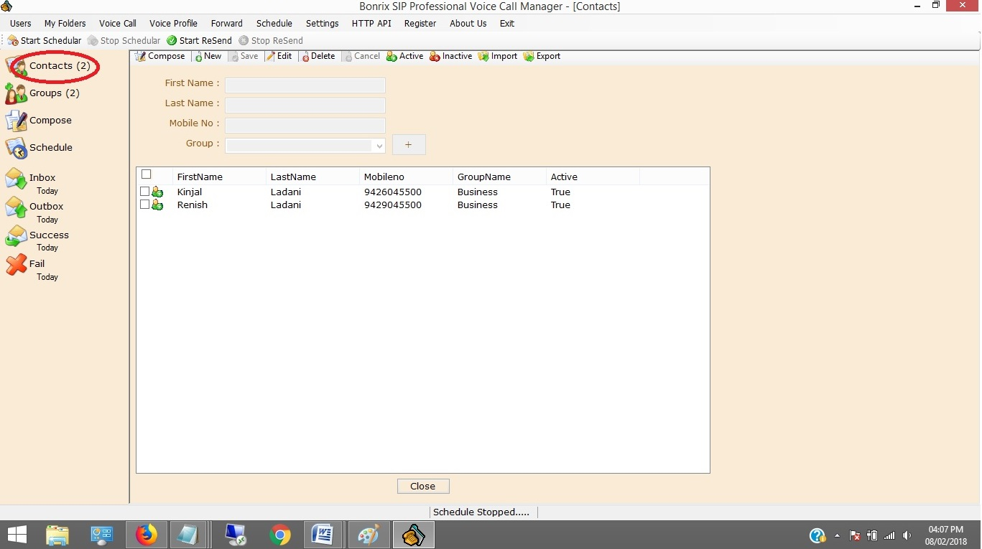

Step 8: go to Groups panel then click on new button and create group as shown in below screenshot. You can Import and Export by clicking on Import & Export button.

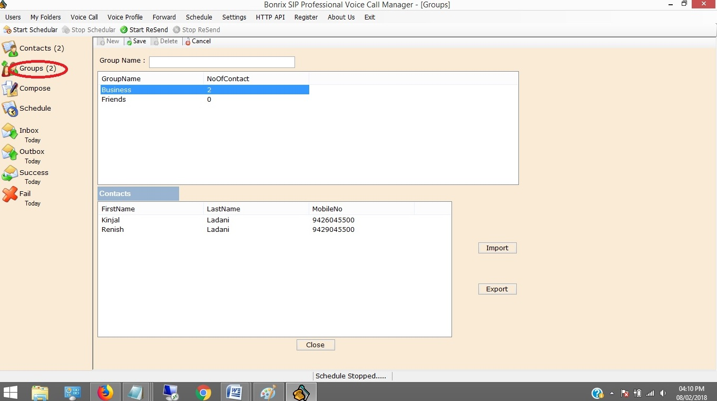
Step 9: Go to Compose Panel and select your call type as per your choice Single, Group Voice Call, Group voice call from file and from Multi Column file.

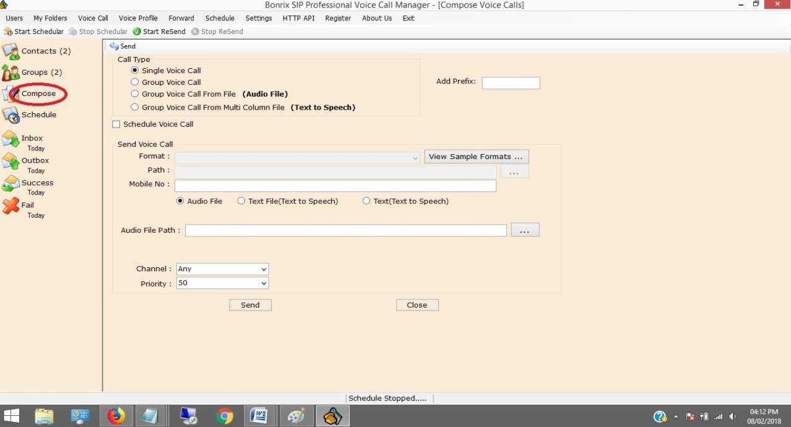

VoIP Devices For Voice Call
- A VoIP Devices uses voice over IP technologies for placing and transmitting telephone calls over an IP network, such as the Internet, instead of the traditional public switched telephone network (PSTN).

- Digital IP-based telephone service uses control protocols such as the Session Initiation Protocol (SIP), Skinny Client Control Protocol (SCCP) or various other proprietary protocols.

- A VoIP telephone consists of the hardware and software components.

- The software requires standard networking components such as a TCP/IP network stack, client implementation for DHCP, and the Domain Name System (DNS).

Several Models of GoIP GSM-gateways
- There Are Various Models of GoIP GSM-gateways:-

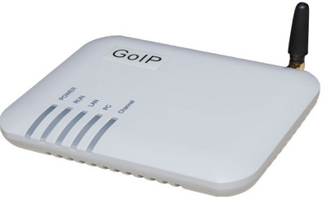 1 Port GSM VoIP Gateway,
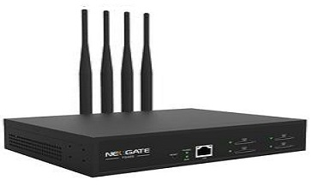 4 Port GSM VoIP Gateway,

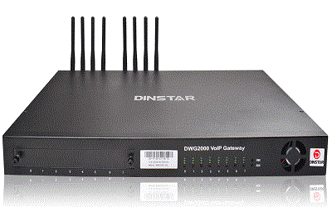 8 Port GSM VoIP Gateway,
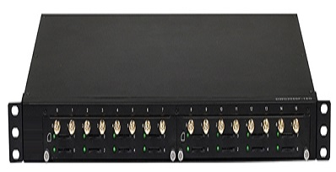 16 Port GSM VoIP Gateway,

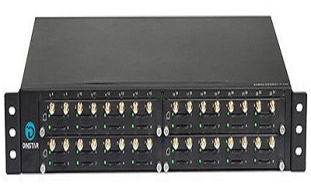 32 Port GSM VoIP Gateway,

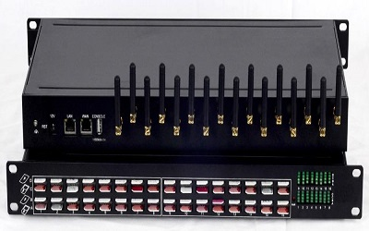 64 Port GSM VoIP Gateway

Applications of GoIP gateways

- They are vastly usable by system integrators, TCP, call-centers, large and little companies and domestic users of VoIP as well.

- Adding the mobile lines in the existing telephone system Organization of outbound call-centers Call transfer from GSM into SIP and backward.

- GoIP provides GSM network between telephone systems and IP PBX, and ensures the fast connection to PSTN where usual telephone lines are unavailable.

Bonrix Voice Functions

1 : Upload Voice File:

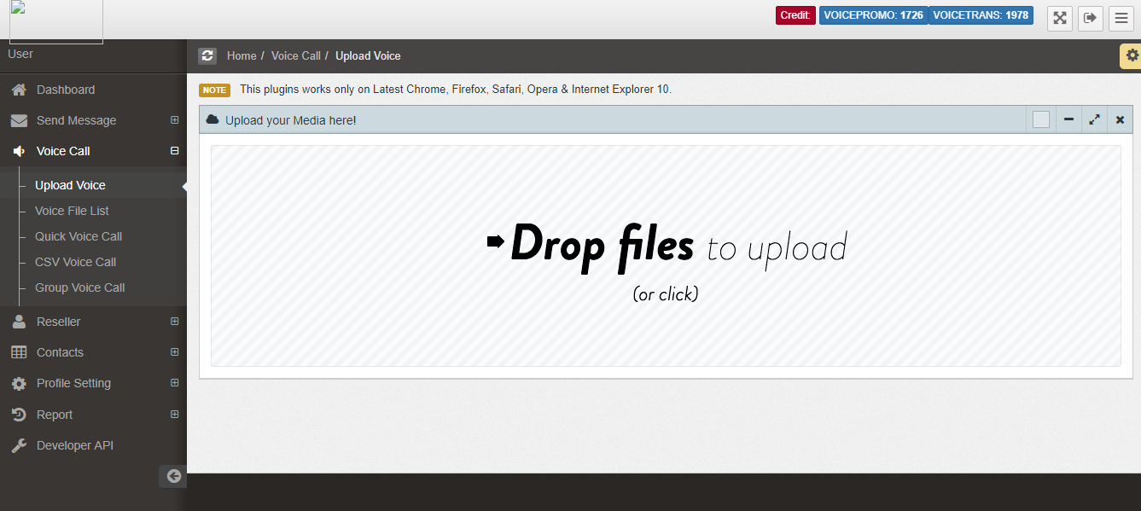

2 : Quick Voice Call:

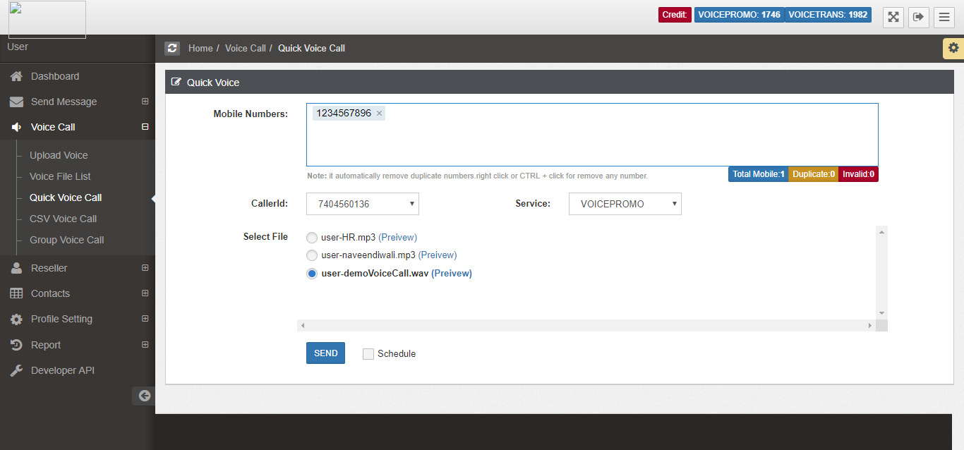
3 : CSV Voice Call:
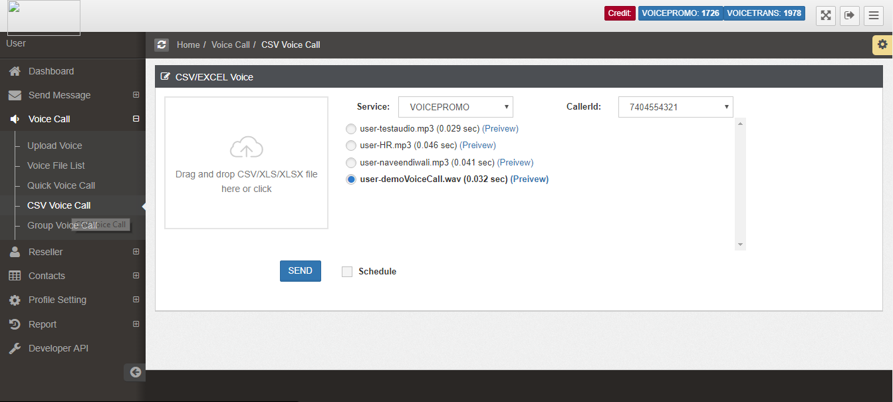

4 : Group Voice Call:

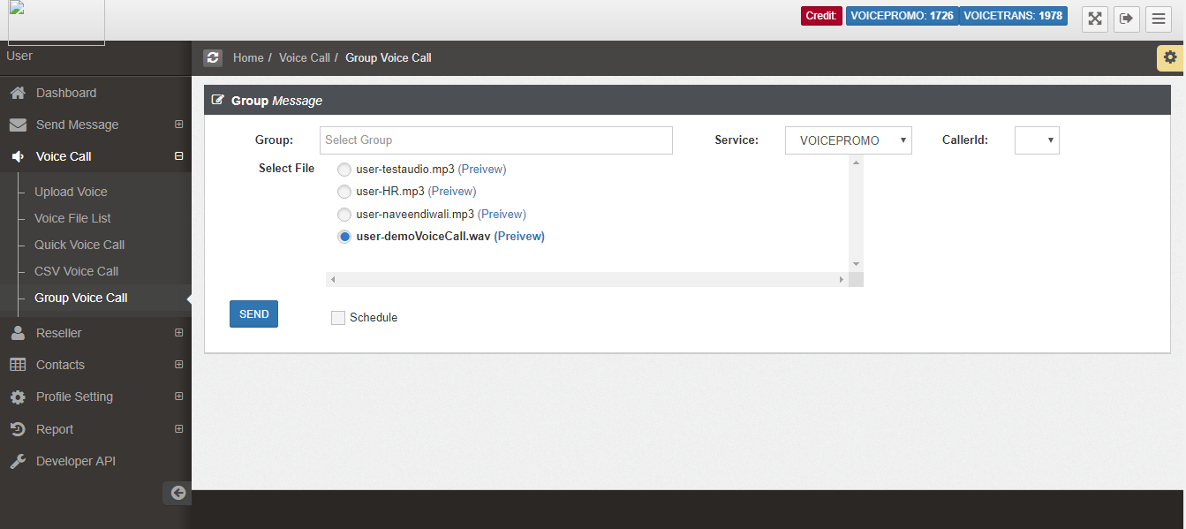

5 : Voice Call Report:
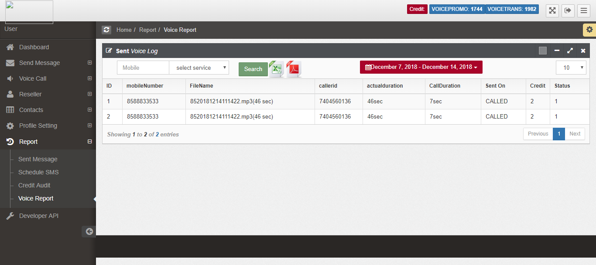

6 : Voice Call Summary:

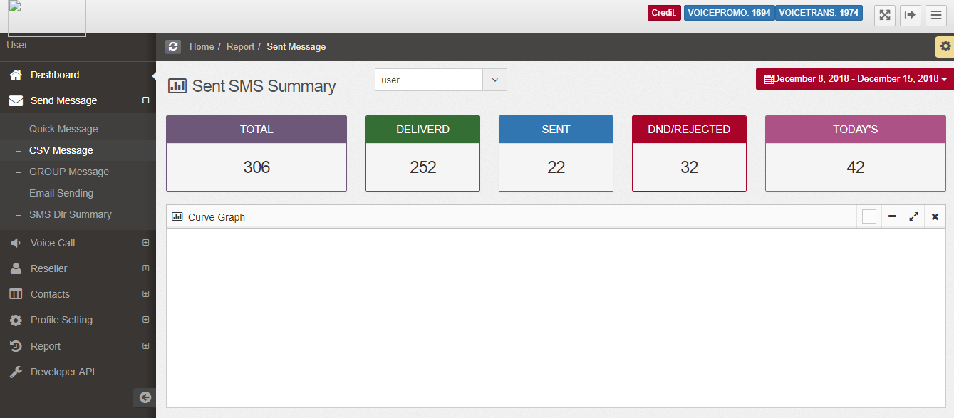

7 : Voice File List:
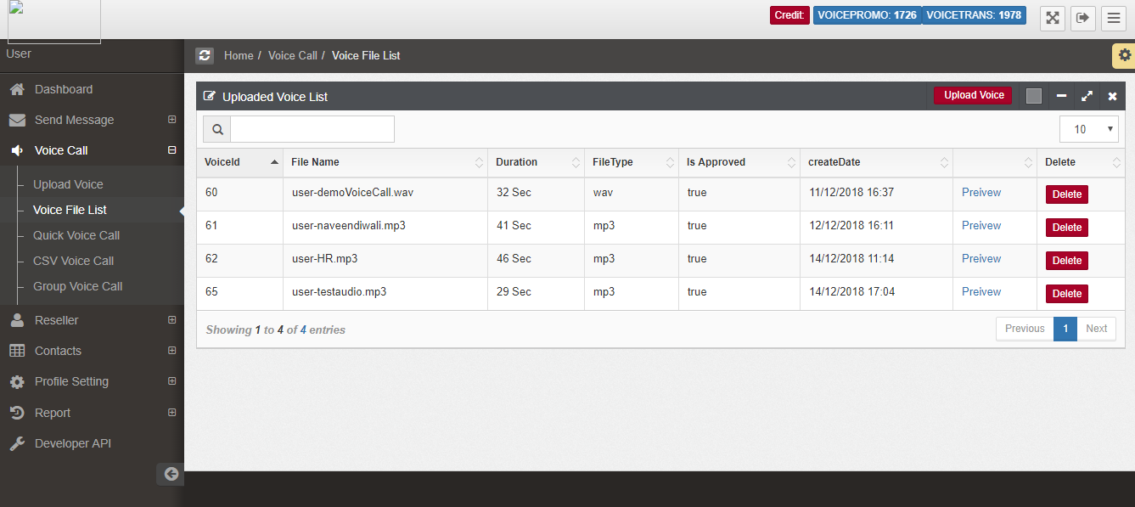

8 : Http API Setting List (Admin Setting):

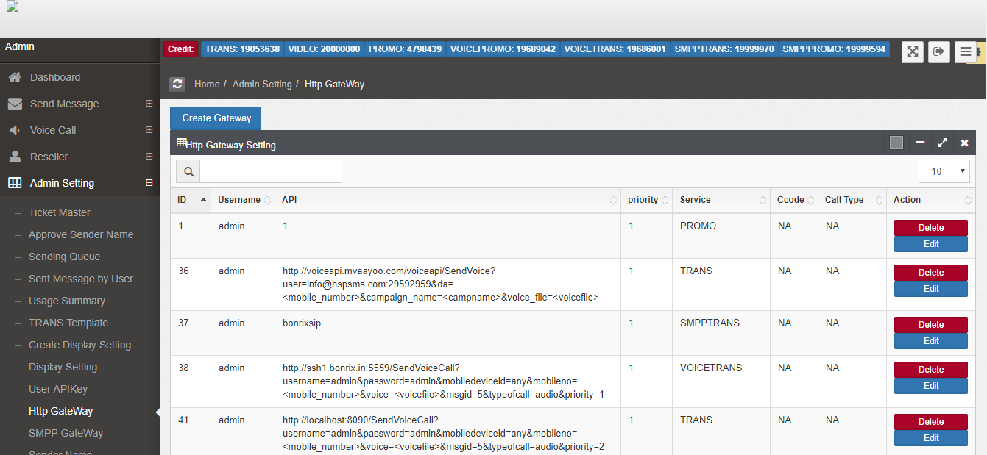

9 : Add Http API Setting (Admin Setting):

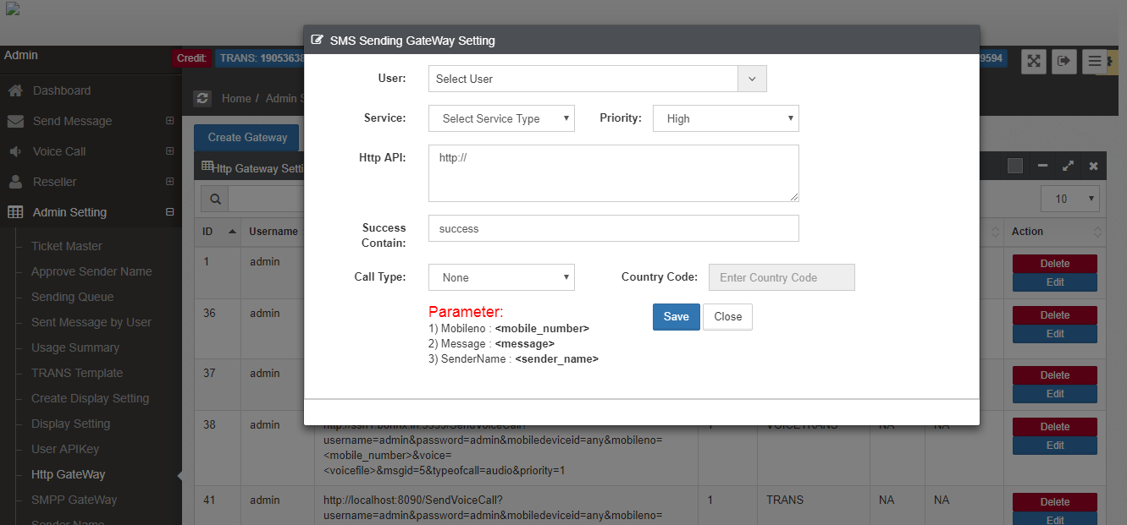

10 : Update Http API Setting (Admin Setting):

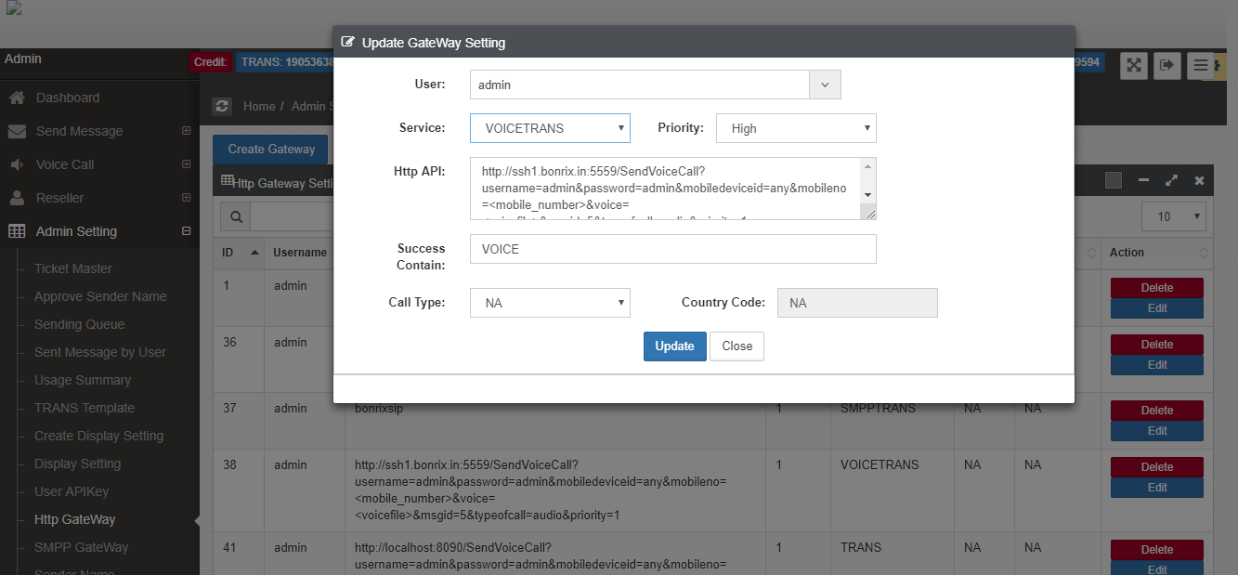
Bonrix Voice Functions

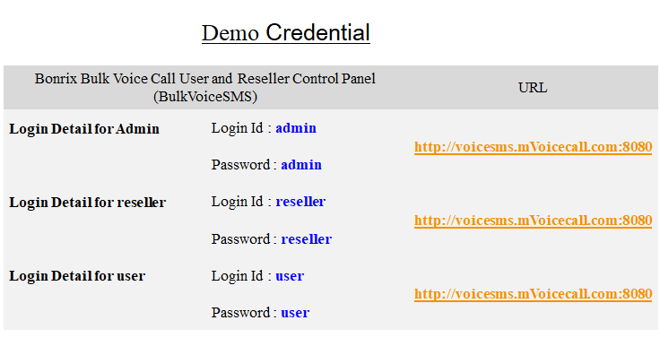

Bonrix’s YouTube video links:
- Bonrix SIP Professional Voice Call Manager Modern Dialer /Auto Bulk voice VOIP Dialer:

https://www.youtube.com/watch?v=t7mkk2ZWIWw
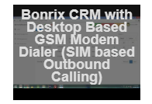
- Bonrix CRM with Desktop Based GSM (SIM based Outbound calling):

https://www.youtube.com/watch?v=cJECzFGTcvU
- Bonrix Voice Broadcast Web Panel for Bulk Voice Call or Group Voice SMS:

https://www.youtube.com/watch?v=Qmj8QgFdXbk

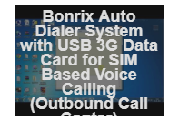
- Bonrix Auto Dialer System with USB Data Card for SIM Based Voice Calling (Outbound call Center):

https://www.youtube.com/watch?v=IqQgZSw8G98
Our Other Product
Android App  http://android.bonrix.net/ | Bonrix  http://www.bonrix.net/ | Bonrix.in  http://www.bonrix.in/
M-Recharge-System  http://rechargesystem.bonrix.in/ | Bonrix.co.in  http://www.bonrix.co.in/ | Call Center Software  www.callcentersoftware.co.in/
GST Bonrix  http://gst.bonrix.in/ | DND Scrub  http://dndscrub.com/ | ePartner Channel  http://www.epartnerchannel.com/
GPS Employer Tracker  http://www.gpstracking.co.in/ | High Speed SMS  http://www.highspeedsms.com | High Speed SMS  http://beacon.bonrix.in/
Live Quoteshttp://www.livequotes.co.in/ | mAndroidPOS  http://www.mandroidpos.com/ | mConfCall  http://mconfcall.in/

Mobile Recharge-System  http://www.mrechargesystem.com/ | My Sales Cloud  http://www.mysalescloud.in/ | My Shopping Cart  http://myshoppingcart.bonrix.in/
My Sms Channel  http://www.mysmschannel.com/ | Notify Me  http://notifyme.co.in/ | Pay Bonrix  http://pay.bonrix.in/
Bonrix Sales Cloud  http://salescloud.bonrix.in/ | Recharge GRID  http://rechargegrid.in/ | Smpp 2 Smpp  http://www.smpp2smpp.com/
SMS via Mobile  http://www.smsviamobile.com/ | SMS via Smpp  http://www.smsviasmpp.com/ | GPS Tracker Bonrix  http://gpstracker.bonrix.in/
Table POS  http://www.tabletpos.in/ | Table POS  http://twittertoolbox.in/ | Bonrix CRM  http://crm.bonrix.in/

GPS  http://www.gpstracking.co.in/ | GPS Tracker  http://www.gpstracker.in/
Address:
M/S. Bonrix Software Systems
A-801, Samudra Complex,
Near Classic Gold Hotel, Off. C. G. Road, Navrangpura,
Ahmedabad - 380009, Gujarat, India.

Contact No:
+91-9429045500,
+91- 9426045500

Website:
http://www.bonrix.net/ & http://www.bonrix.co.in/
http://mvoicecall.com & http://archive.mvoicecall.com/

Email Id:
bonrix@gmail.com

